S3

1) Create s3 bucket and upload some objects to s3.

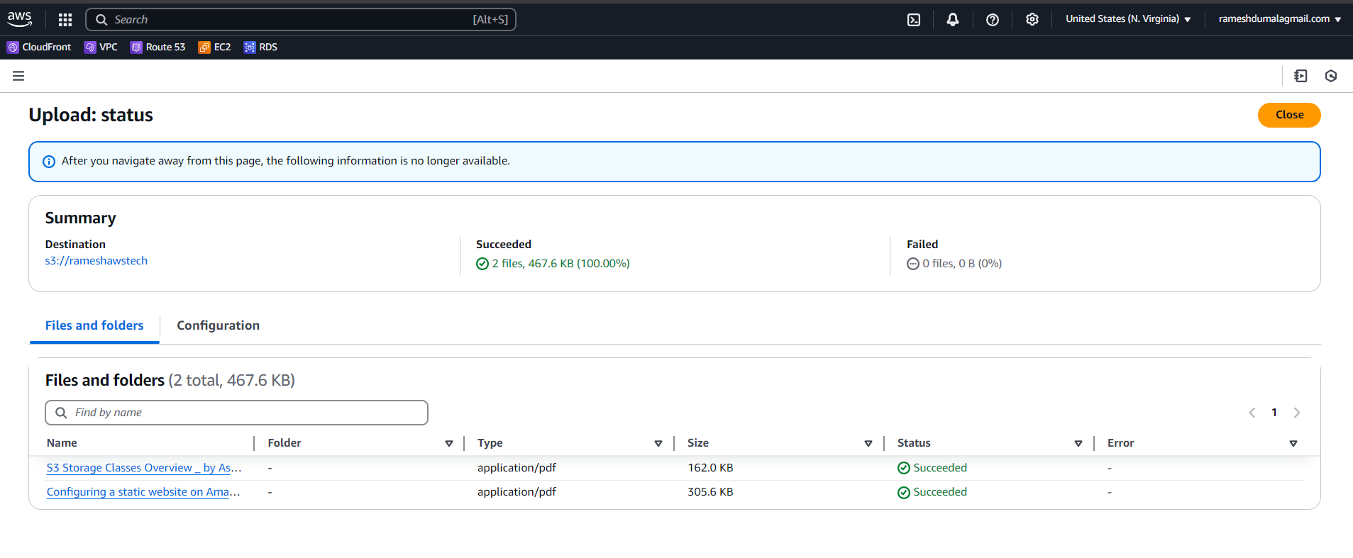

I have created a bucket and i added the two files

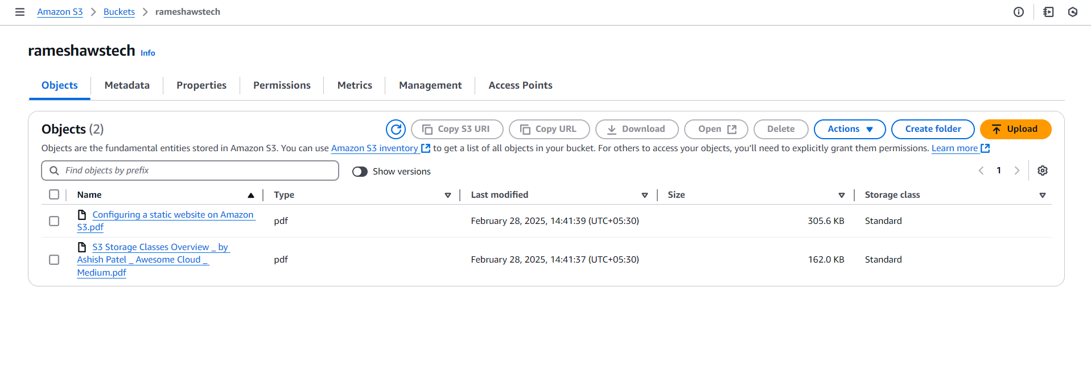

2) Deploy static website in s3 bucket.

I got an issue before creating policy to access public 403 forbidden

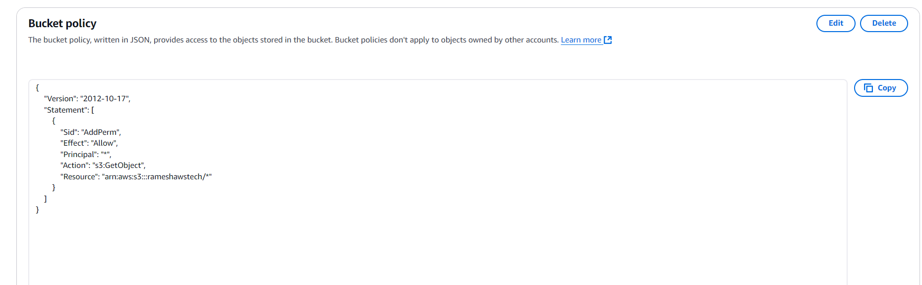

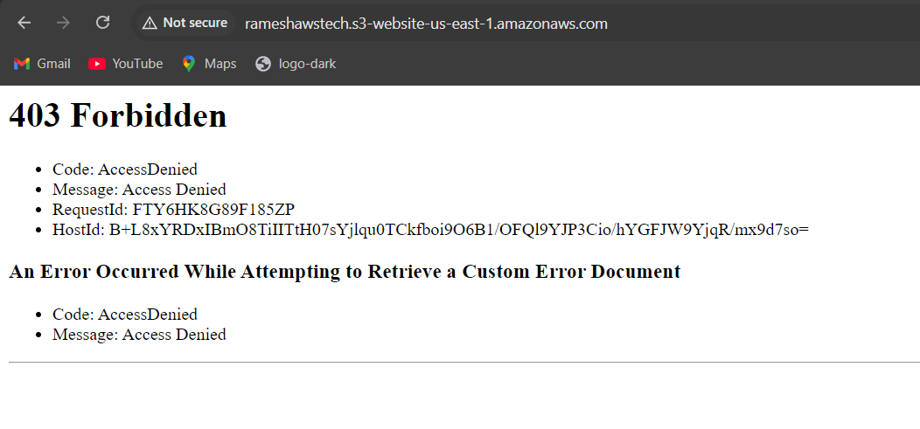

After resolving the issue about ppolicy again i found 404 because of i did not create a .html file

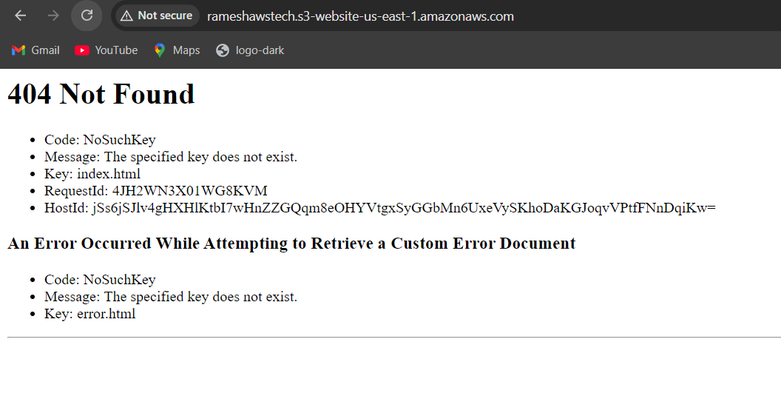

After resolving all the issues i got a propert output

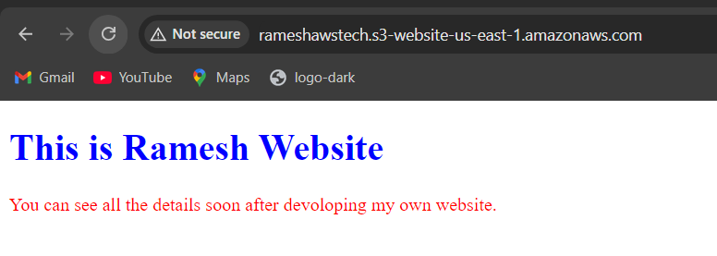

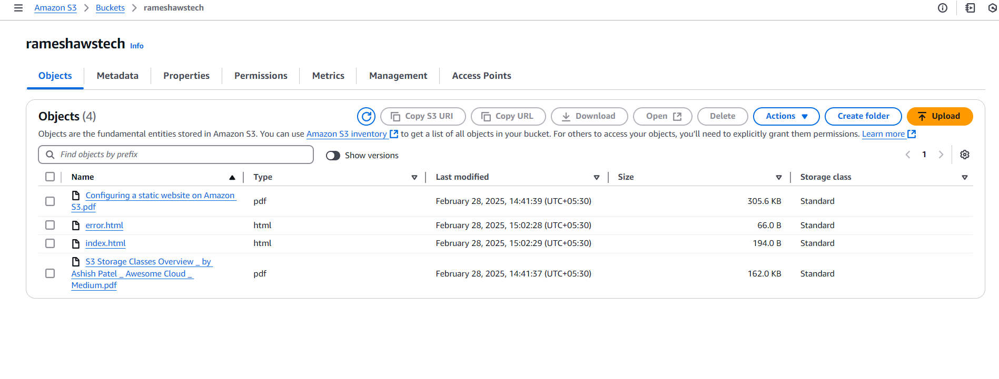

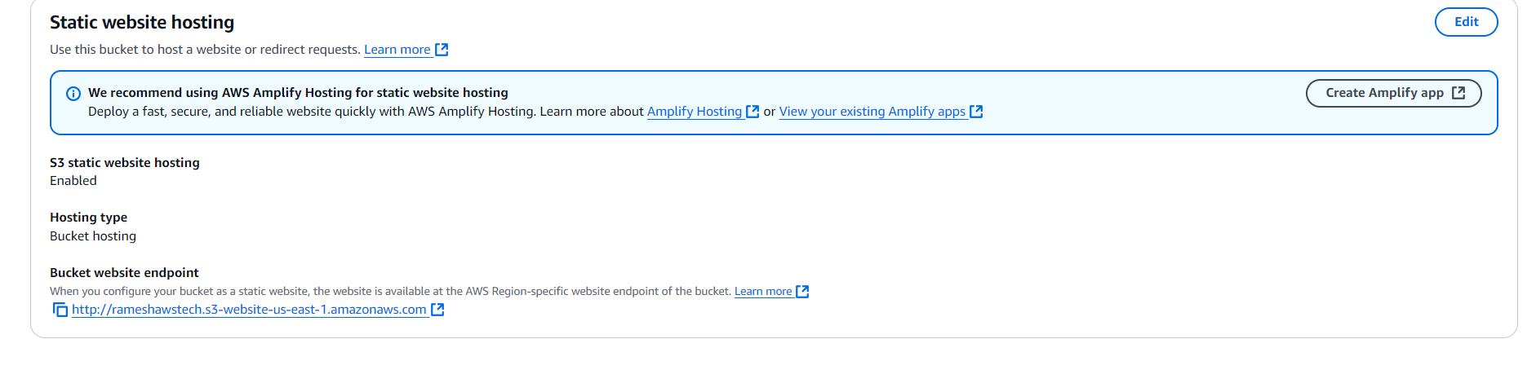

This is my error page

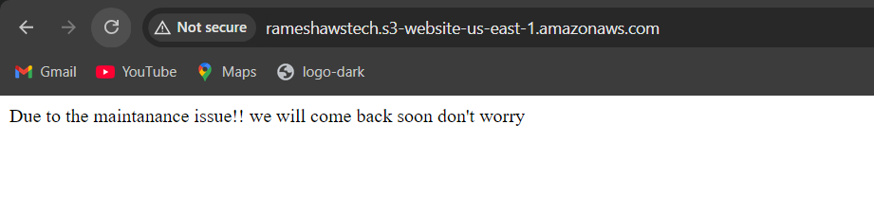

3) Enable cross region replication on s3 buckets.

I have created a crr and create a role for it

This is my destination bucket created in ohio for cost optimization was taken storage class as glacier

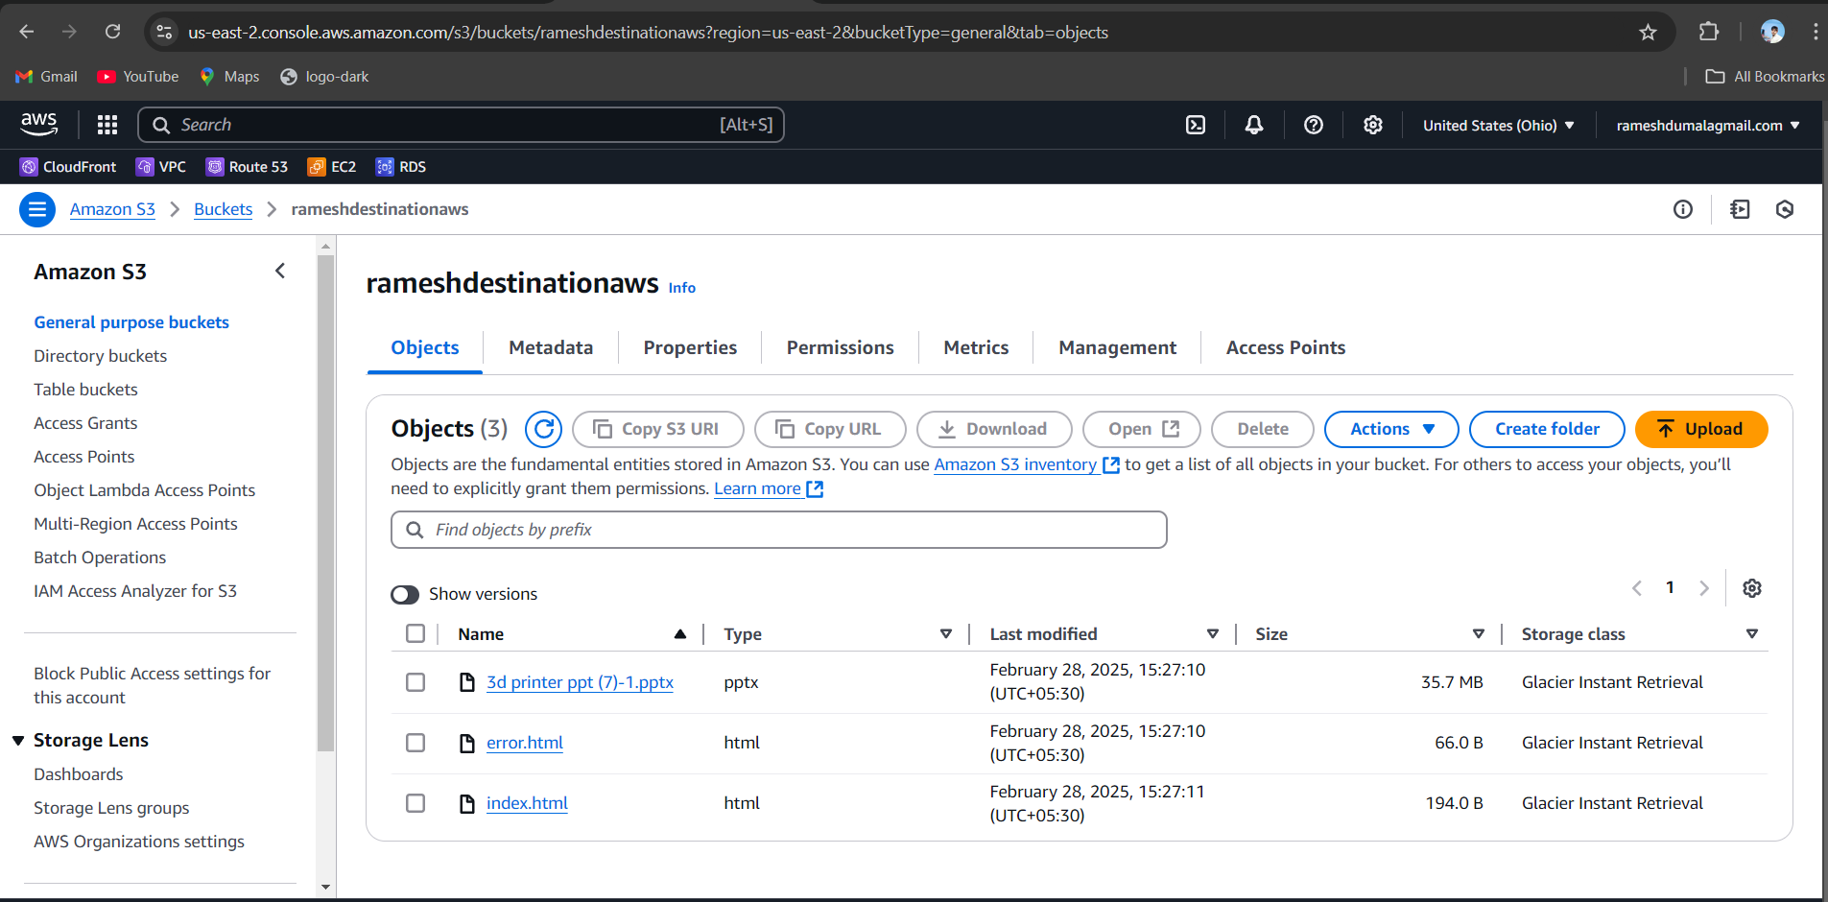

This is my source bucket where i uploaded my file int is in virginia region

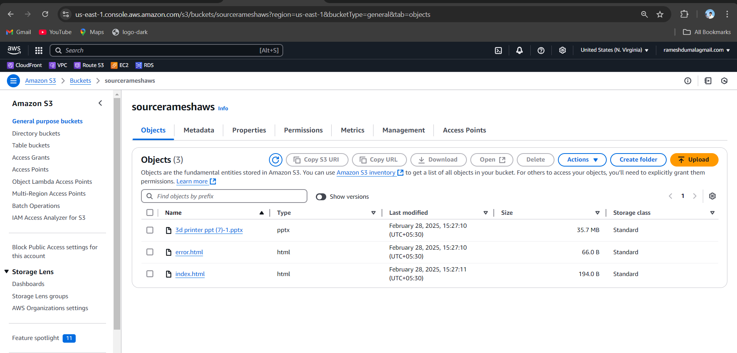

4) Configure bucket policy,only Admin user can see the objects of s3 bucket.

I have created a admin user name ramesh and i attached to the bucket policy to allow this user only

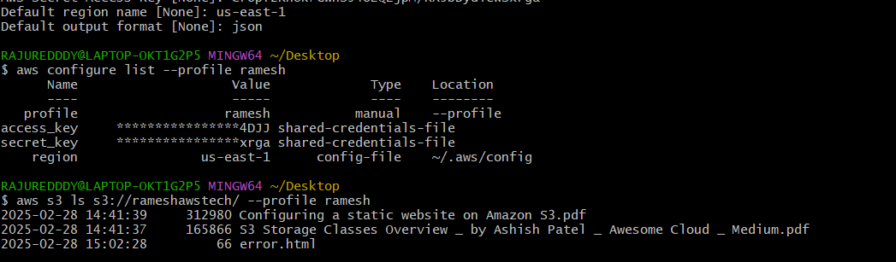

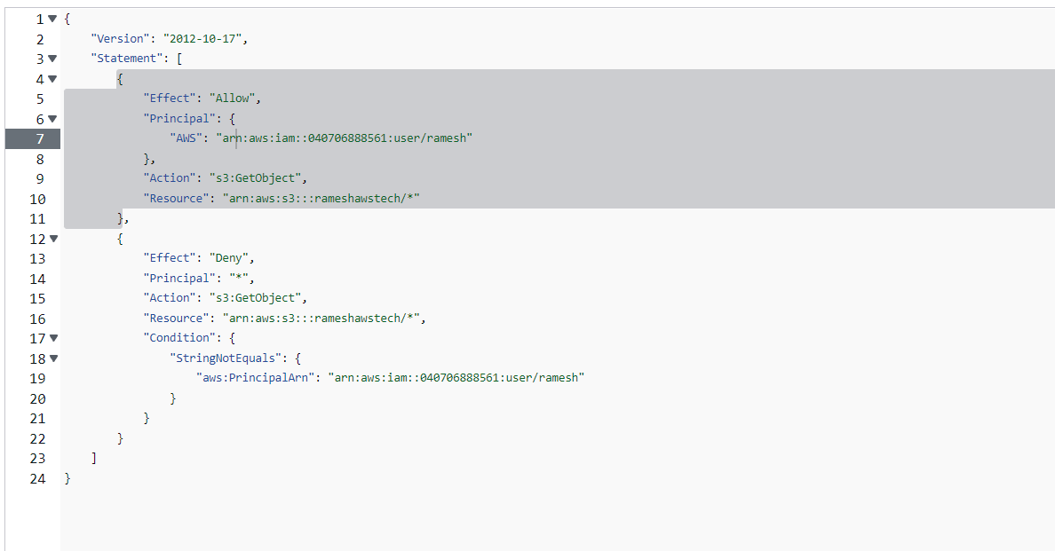

5) Setup lifecycle policies to automatically transition or delete objects based on specific criteria.

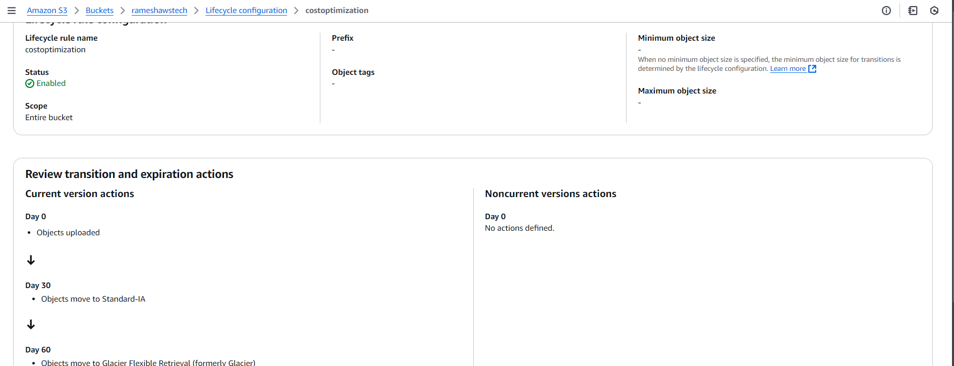

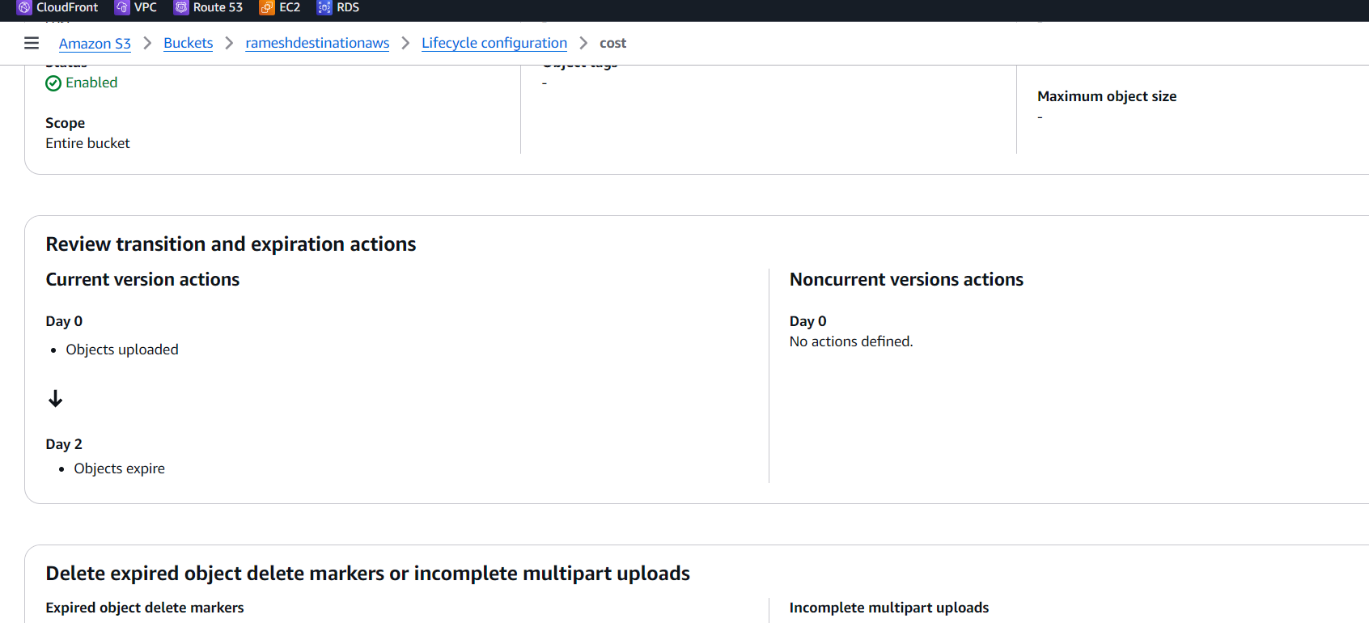

6) Push some objects in s3 using AWS CLI.

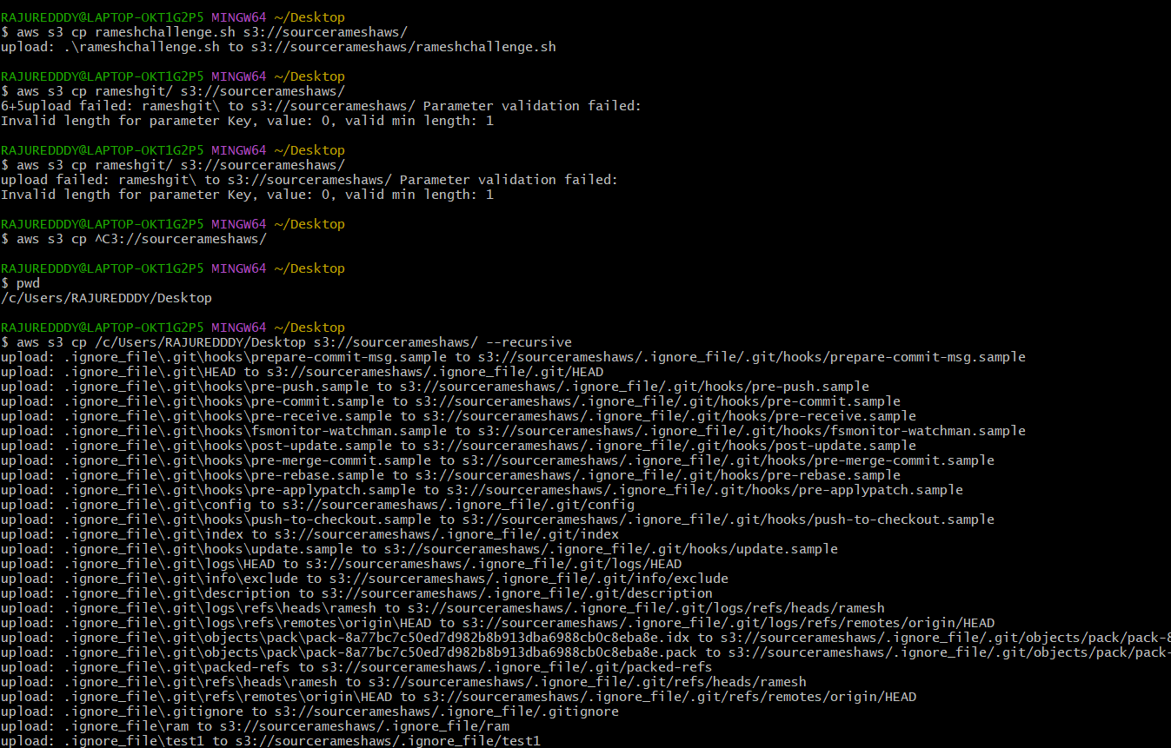

8) Upload one 1 gb of file to s3 using cli.

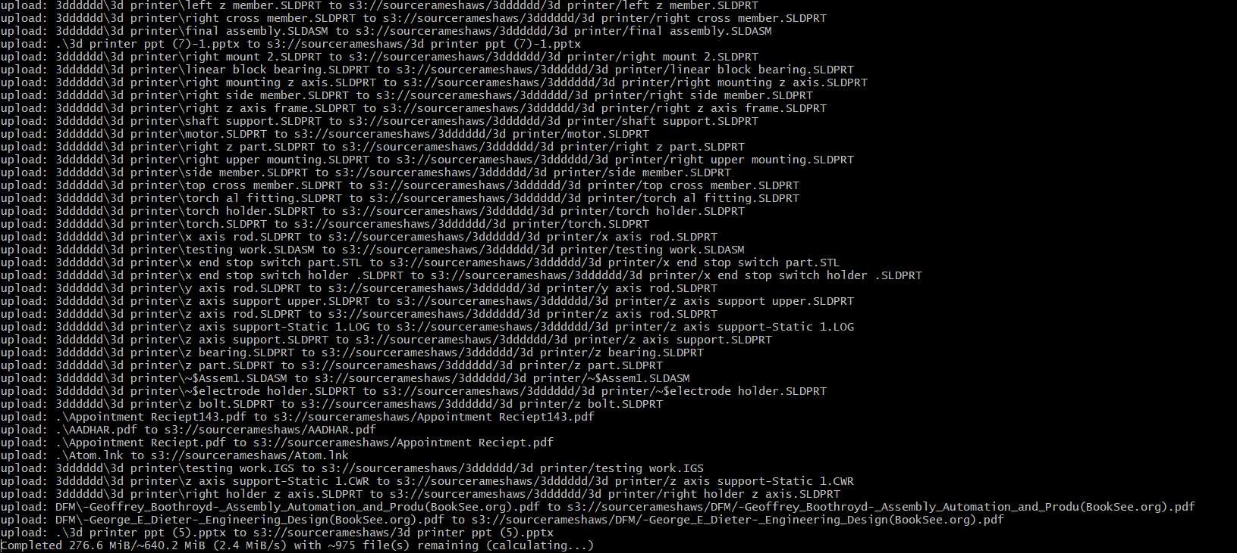

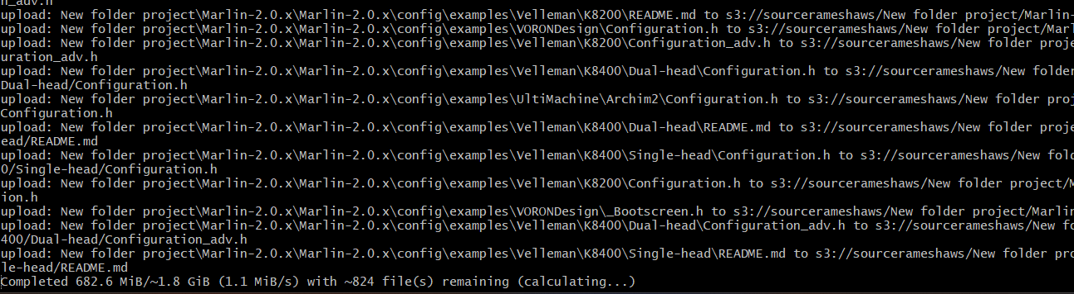

7) Write a bash script to create s3 bucket.

